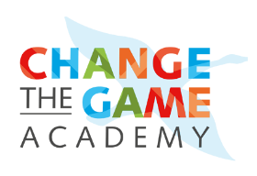

1. Vendor & Tool Vetting Checklist
Use this checklist to assess whether a vendor or tool aligns with your nonprofit’s values and AI policies.
☐ Does the vendor disclose where and how training data is sourced?
☐ Are there documented procedures to mitigate bias in the tool?
☐ Does the tool allow for user control, human oversight, and transparency in outputs?
☐ Is there a clear explanation of how the algorithm works (explainability)?
☐ What data security certifications or audits does the vendor comply with (e.g., SOC 2, ISO 27001)?
☐ Can the vendor demonstrate compliance with applicable regulations (e.g., GDPR, CCPA)?
☐ Are support and documentation comprehensive and up to date?
☐ Does the vendor provide impact assessments or case studies from nonprofit clients?

